8.16: a) The final momentum is

taking positive directions to the right. a) Before the collision, puck B was at rest, so all of the momentum is due to puck A’s motion, and

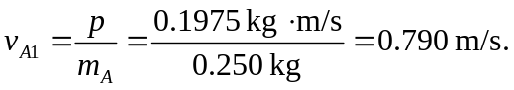
b) 